YUCHENG PTZ IP Camera Manual

**[Part 1: Connect and manage cameras using mobile APP]**

Please go google play or Apple store download mobile APP,the name is Videolink and install it into your mobile phone

The first time you run the APP, (<http://www.esunstar.net/videolink-Download.html>).you need to register an account. You can use your email or mobile phone number to register an account, and then use the registered account to log in to the APP.

**[1], Configure the camera using WIFI**

1. If your camera has WIFI function. Before connecting the power adapter of the camera, please make sure that the LAN port of the camera is not connected to the Ethernet cable (if you have connected it, please disconnect it and press the reset button for 5 seconds to restore the camera to factory settings). After connecting the power, wait 10 seconds.

2. Before using the mobile APP to configure the camera, please connect your mobile phone to your WIFI router via WIFI.

3. Open the APP and click the Add button to add a camera (as shown in Figure 1). And select WIFI (as shown in Figure2), the software will automatically obtain the WIFI of the mobile phone, and please enter the WIFI password (the WIFI connection password of the wireless router). Click Next (as shown in Figure 3)

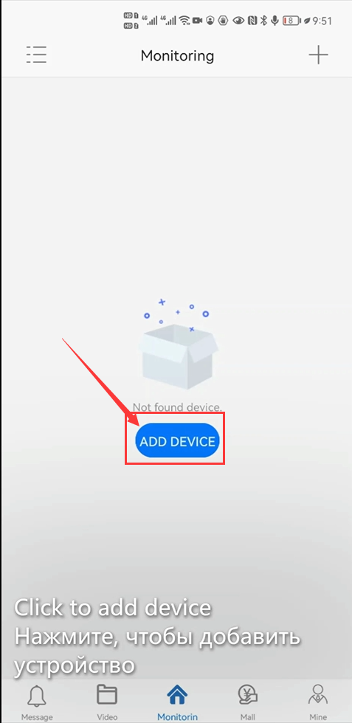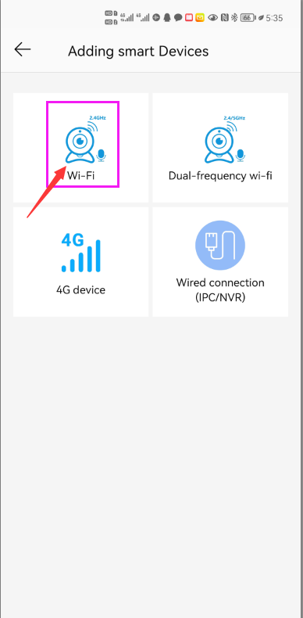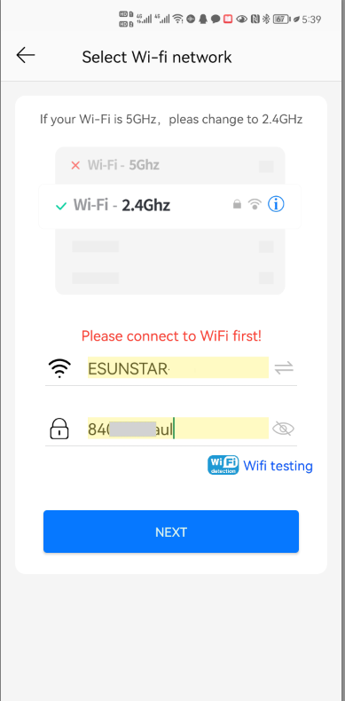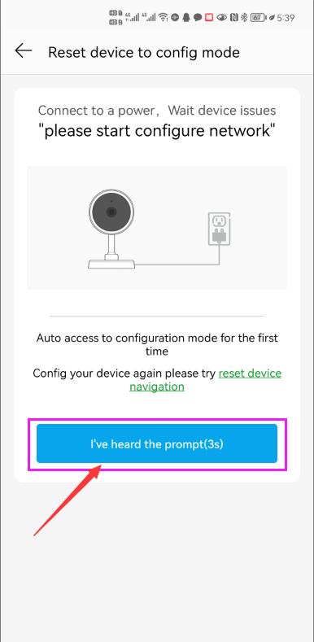

1 2 3 4

After entering the interface of Figure 4, wait for a few seconds, the APP will automatically enter the interface of Figure 5, and the camera will start to match the code through sound waves. When you hear a "di" on the phone, it means that the camera is successfully connected to your wireless router via WIFI (as shown in Figure 6). If your camera does not have a microphone and a speaker at the same time, the sound wave code matching cannot be completed, but you can also add the camera after aligning the QR code on the phone screen with the camera lens. Click the camera on Figure 7, and you will enter the camera's monitoring and management interface (as shown in Figure 8). The camera has been added successfully.

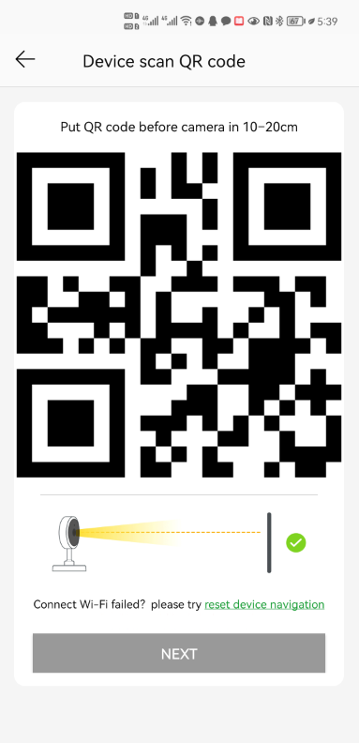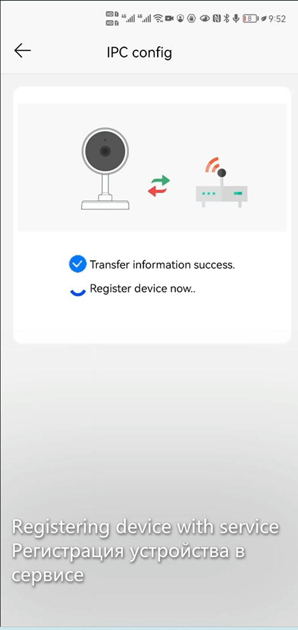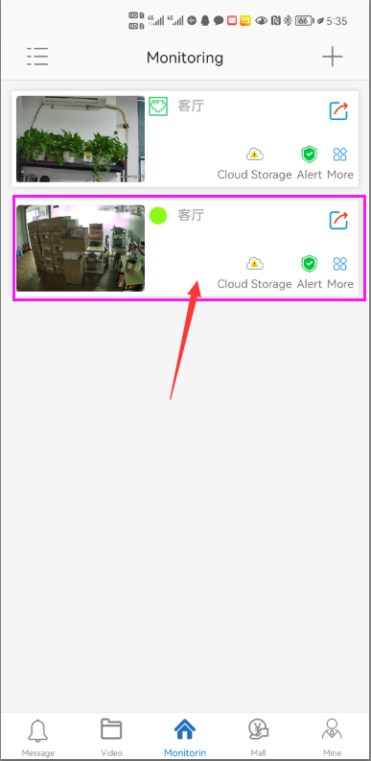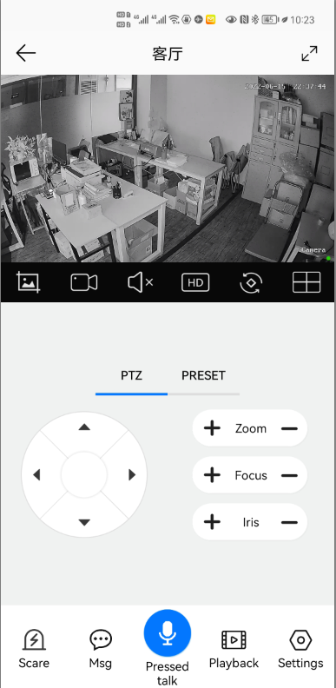

5 6 7 8

**[2], Add a camera by scanning a QR code**

If your camera does not have WIFI function, please connect the ethernet cable to your switch/router and connect the power adapter. Select "Wired connection camera", as shown in Figure 9, enter the interface of scanning the QR code to add a camera, point the mobile phone at the QR code on the camera body to scan (as shown in Figure 10), after scanning is successful, please provide your Customize a name for the camera, and click "BIND IT" to complete the addition (as shown in Figure 12)

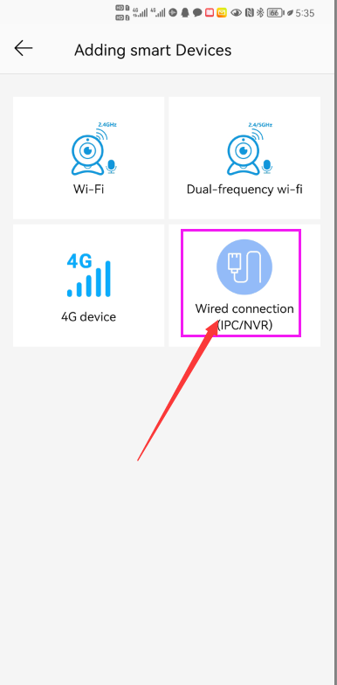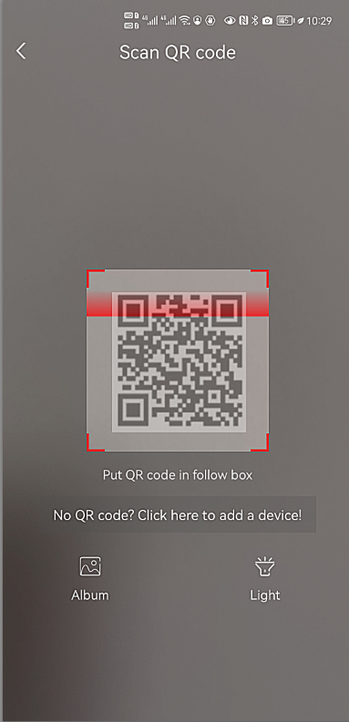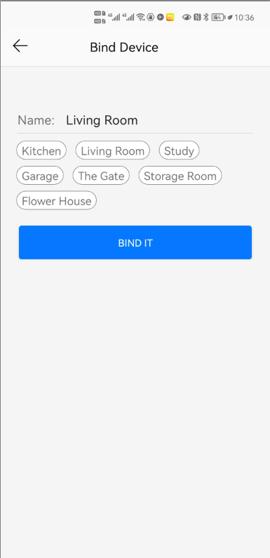

9 10 11 12

**[3], Add cameras via LAN connection**

If the QR code cannot be found on the camera, you can click "Click here to add a device" to add the camera through the LAN search (as shown in Figure 12), enter the search page, and the APP will automatically search for the camera, as shown in Figure 13 display, and then click the camera to complete the addition.

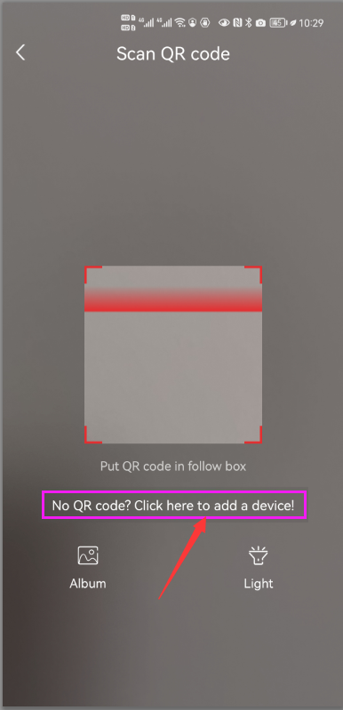 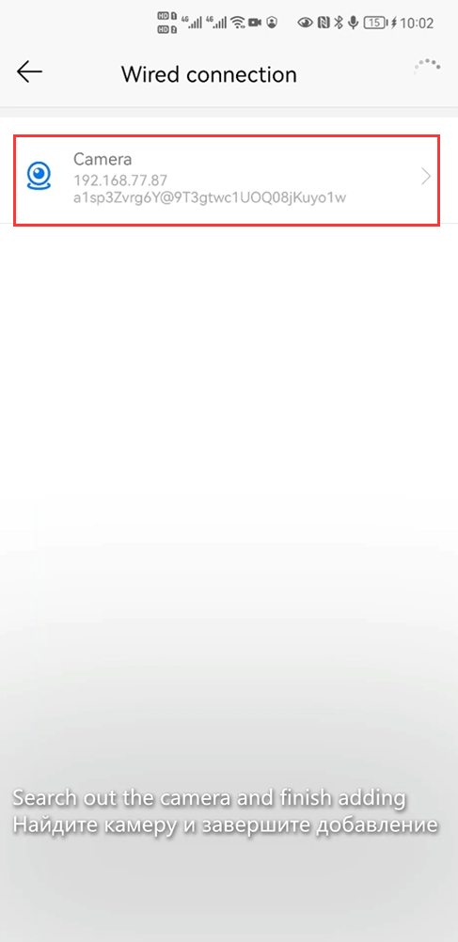  

13 14 15 16

**[4],How to Turn on/off auto humanoid Tracking**

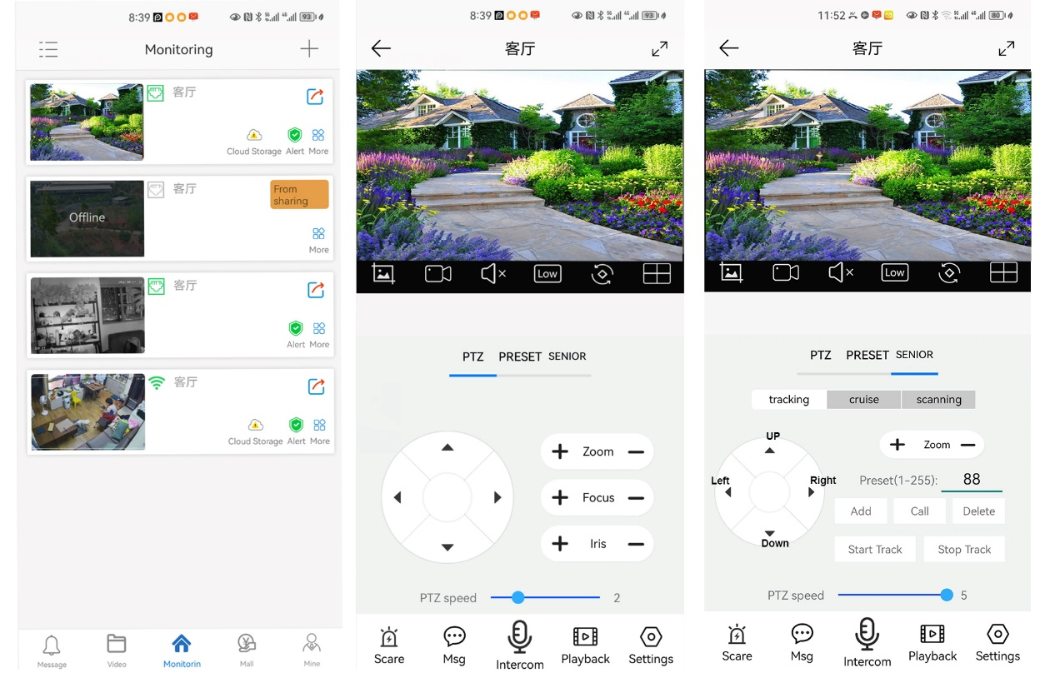

1 2 3

**Fixed Position Tracking**

1,Control the PTZ button to rotate the camera to your desired position (set a Return position)

2. Switch the PTZ control interface to “SENIOR” setting interface.

3,Input 88,Then click “Add” button.The tracking return position(Home position) set successfully

4,Click "Start Track" button, The camera will automatically turn on the tracking function

5,Click ”Stop Track” button,the camera will automatically turn off the tracking function

**Cruise tracking:**

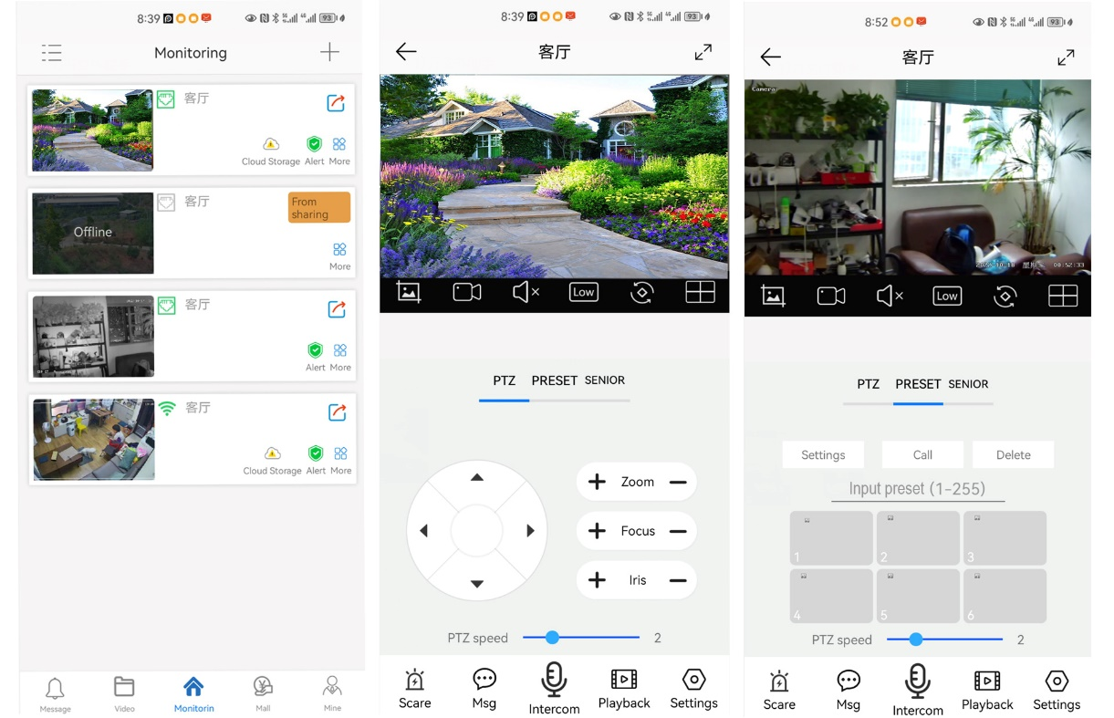

1 2 3

Before turning on cruise tracking, you need to set the camera's cruise point in “Preset”. A maximum of 64 preset points can be set. These cruise points are the few locations you want to monitor. The camera will cruise back and forth between these locations to find a tracking target. Really made a camera monitors multiple angles of demand. Turn on cruise trackingfunction,The camera will cycle moving through the preset cruise points. When the person is detected, the camera will turn on the tracking. After the tracking is completed, the camera automatically resumes the cruise until the next time the person is detected, the tracking is turned on again

Set 1,2,3,4….max 64 preset position,Then call 98th preset camera will auto turn on cruise tracking. Setting method: [98]+[Call] for turn on cruise

**Part 2: Add and manage cameras using PC software**

**[1],Install search tool on your PC(**[**http://www.yucvision.com/upload/file/AjDevTools_V5.4.2_20221024.exe**](http://www.yucvision.com/upload/file/AjDevTools_V5.4.2_20221024.exe)**)**

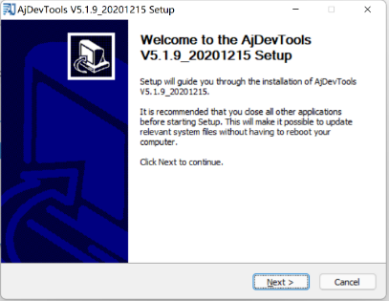 1,Run” AjDevTools_V5.1.9_20201215.exe” and complete the installation

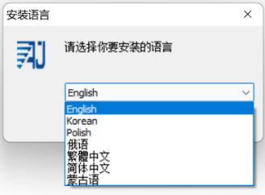 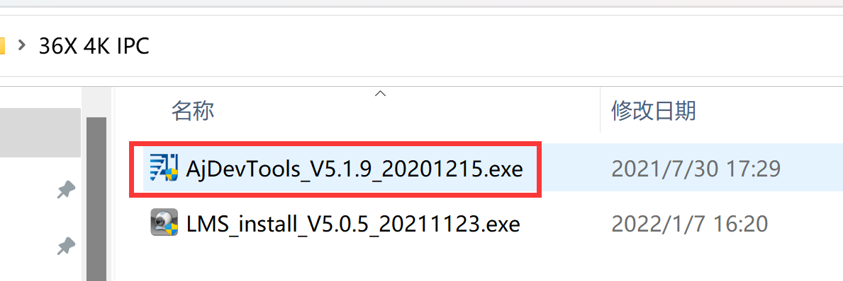

1 2

3

2, Run the software, as shown below（4）

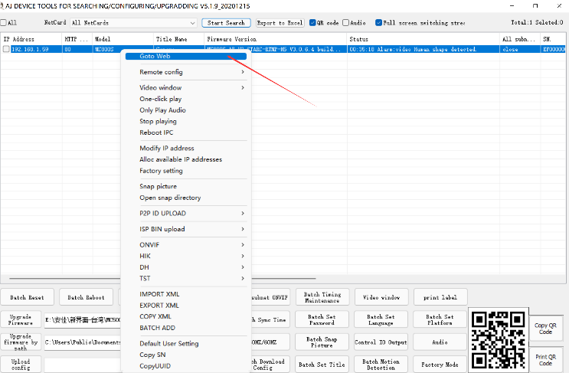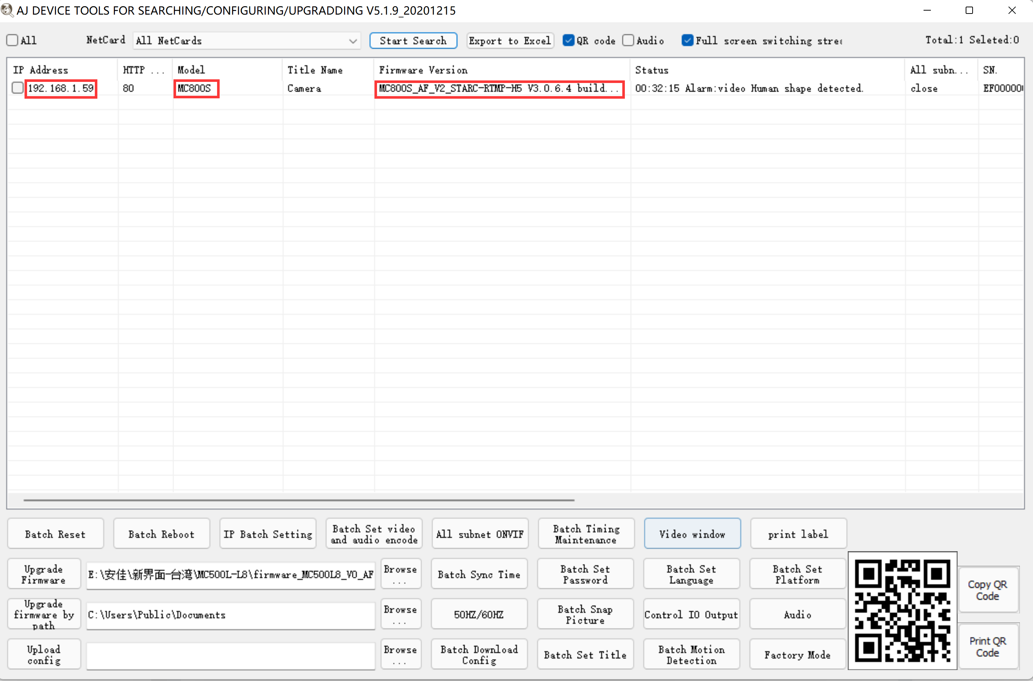

4 5

3, Here you can modify the IP address of the camera, upgrade the firmware and other parameter settings. Right-click on the IP address to open the camera with a browser, as shown in the figure 5.

4,Enter the browser login interface, login user name: admin, password: 123456, as shown in the following figure (if the browser prompts you to download and install the plug-in, please download and install it): Then click login ，as shown in the figure 7

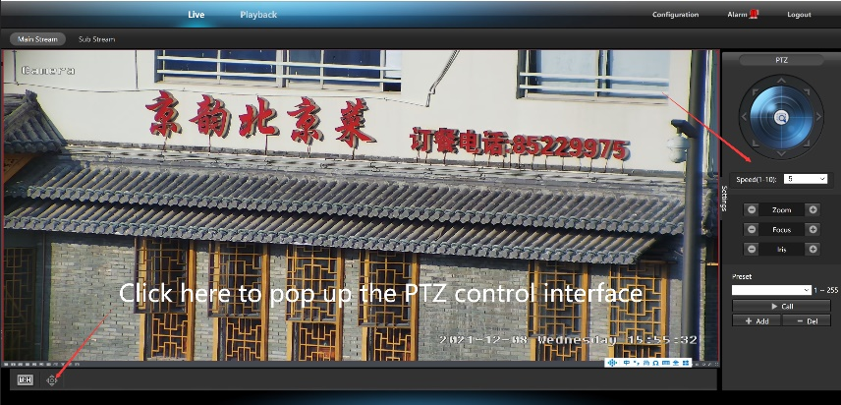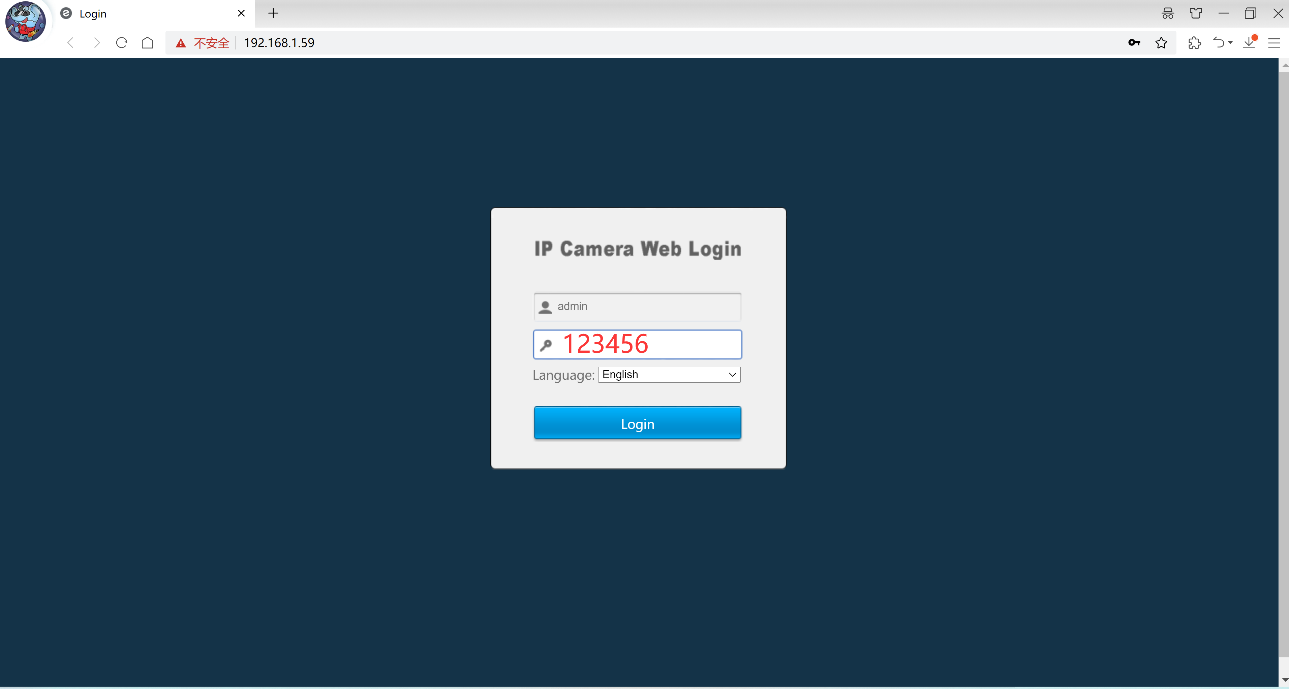

6 7

**[2],Use PC software to search and add cameras(**[**http://www.yucvision.com/upload/file/LMS_install_v5.0.9_20220923(KP).exe**](http://www.yucvision.com/upload/file/LMS_install_v5.0.9_20220923(KP).exe)**)**

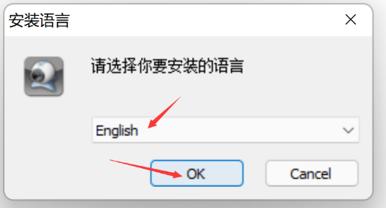1，Install the LMS computer software.

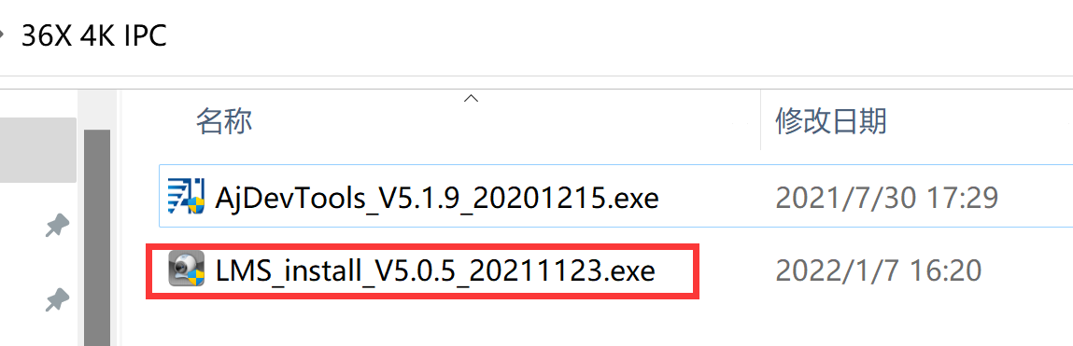

8 9

The software supports English, Simplified Chinese and Traditional Chinese (if you want to support other languages, we can provide you with language packs, you can translate into the language you want, and then we can provide you with software customization)

2，Follow the prompts to complete the software installation

3, Run the LMS software:user:admin,password:123456

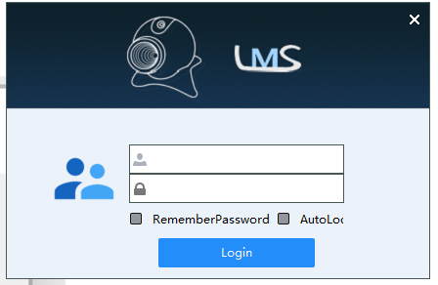

Click LOGIN to log in to the software

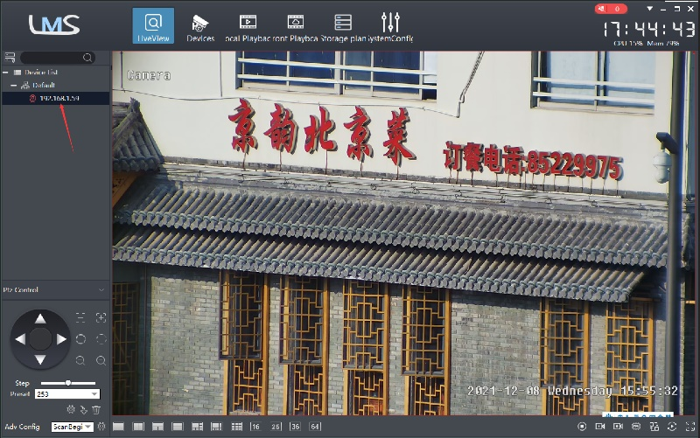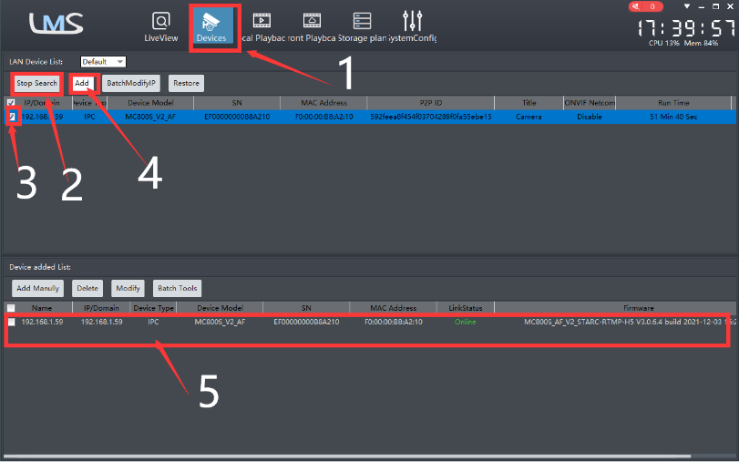

10 11

4. Search and add cameras.Click “Devices>””Start Search”>click“3”>add >successfully added，as shown in the figure 10

Then click” ” go to Liveview, as shown in the figure 11

Double click on the IP address and the video will automatically appear in the video box on the right.

**[3],** **Preview and control cameras with AC18PRO PC software**

1, Double-click the AC18PRO software in the directory, follow the prompts to complete the installation of the camera, and then run the camera. <http://www.yucvision.com/upload/file/AC18Pro_install_V2.0.5_20221017(support%20world).exe>

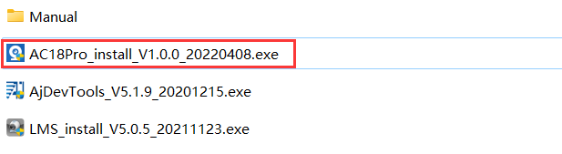

**2,run and login AC18PRO,**

The username and password here are the account you registered for the first time on your mobile phone.

Click login button go to AC18PRO

You will see all the cameras under your account, you can preview the

cameras and view the video playback in this way

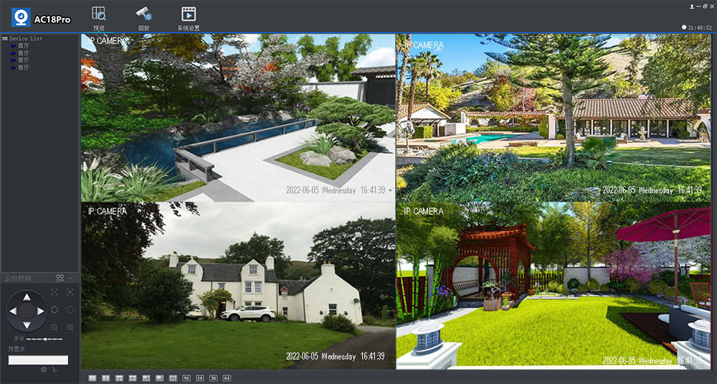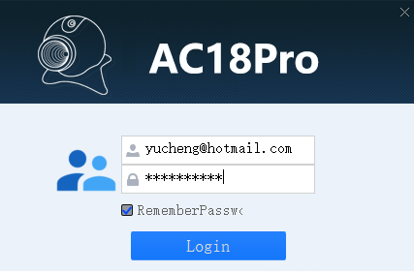

**Part 3 【Function Operation and Description】**

**Professional name explanation: Settings/Add:set preset, Call:Call preset, [N]+[set]=**Enter N first and then click SET**.“+”=Then**



**1**,**Preset settings**

Rotate the camera to the position you want, then set this position to “N” preset

 [N] +[SET] ,N is preset point, 1-255 number can be optional (But the command Preset isn’t include). Set= set preset

**2.Call preset( need set the corresponding preset point) :**  [N]+[CALL]

N for preset point, 1-255 number can be optional, camera can move to preset point after call, Zoom, focus and aperture lens will automatically change to preset parameters , camera preset display on the monitor.

**3.Delete all preset point:** [100] +[CALL] ,Call no.100 preset, clear the all preset :[1]+[0]+[0]+[CALL] .

**4.Auto scan(Horizontal rotation)**

[120]+[CALL], call No.120 ,the lever of 360 degree clockwise automatic scanning

**Modify speed of Auto scan :**

[121]+[Set] +[N]+[Set]; (N=1-10; N represents scan speed percentage,default is 8=80%)

If you wanto to change speed of auto scan to **50%**; Setting method: [121]+[Set] +**[5]**+[Set]

**5,The inspection group programming**

Before you start cruising, you first need to set the preset position in the cruise path.**Please refer to “ 3.Preset settings”**

[101]+[CALL] for Open the first Cruise of 1-64 to scan ；

**Modify the stay time of the Cruise:**

[123]+[Set] + [N]+[Set]; (N=3-10; N represents the dwell time at each preset,default is 5 seconds)

If you change the dwell time to **10 seconds**. Setting method:[123]+[Set] + **[10]**+[Set]

**Modify speed of the Cruise:**[115]+[Set] + [N]+[Set]; (N=1-10; N represents Cruising speed percentage,default is 8=80%)

If you change speed of the Cruise to **40%**; Setting method:[115]+[Set] + **[4]**+[Set]

**6,Left and right limit scan settings**

The users can set left and right limit point in the range of the rotation, the speed dome can return scan in setting range [81]+[SET]: left limit; [82]+[SET]: right limit, [83]+[CALL]: start right and left limit scan

**Modify the speed of right and left limit scan:**

1. +[SET]+[N] +[SET]; (N=1-10; N represents Cruising speed percentage,default is 5=50%)

If you change speed of the limit scan to **100%**; Setting method:[141]+[Set] + **[10]**+[Set]

**7.Idle** action **settings:The camera performs a certain function in standby mode**

[130]+[set]:OFF Idle position set

**Idle position setting:**[131]+[Set]+[N]+[Call],

N=Function preset;When N=98, the camera Open the first Cruise of 1-16 to scan function. Setting method:[131]+[SET]+ [98]+[CALL]  
Set the time when the idle action start: [132]+[set]+[N]+[SET]; (N=1-30; N represents Idle time,default is 5 minutes)

**8.Restore factory settings for Speed dome**

  [106]+[Call]+[64]+[CALL] for restore PTZ speed dome to factory setting；Setting method:[106]+[Call]+[64]+[CALL]

**Part 3 Speed dome Command Table**

|  |  |  |  |  |
| --- | --- | --- | --- | --- |
| **Command Name** | **Function description** | **NO.** | **Call** | **Set** |
| **Tracking Command** | | | | |
| Set a Return Position | This position is the initial position where the camera starts tracking/the automatic return position after tracking:88+set | 88 |  | **√** |
| Turn on fixed-point tracking | Turn on tracking based on initial position:97+call | 97 | **√** |  |
| Set tracking return time | The time when the camera automatically returns to the initial position after the tracking target disappears:153+set+N+set,N=1-15 seconds， default N=5 | 153 |  | **√** |
| Turn on cruise Tracking | Camera activation is based on preset position cruise tracking (some preset positions need to be set first (range: 1-32)):98+call | 98 | **√** |  |
| Turn on limit scan tracking | 86+call | 86 | **√** |  |
| Turn on 360°Pan scan tracking | 85+call | 85 | **√** |  |
| Turn off all Tracking | 96+set | 96 |  | **√** |
| tracking Enable ZOOM | The camera automatically ZOOM when tracking:95+set（default） | 95 |  | **√** |
| Tracking invalid ZOOM | The camera invalid ZOOM when tracking ，95+call | 95 | **√** |  |
| Set continuous Tracking | As long as the tracking target does not disappear, the camera will continue to track :92+call+7+call（default Enable） | 92 | **√** |  |
| Time limited tracking | The camera automatically returns to the initial position when the camera continuously tracks the target for a certain time :92+call+8+call | 92 | **√** |  |
| Settings Time limited tracking time | 93+call+N+call（N=1-60秒），default N=20 seconds | 93 | **√** |  |
| Precautions for time limited tracking | 1. After switching time limited tracking for the first time, you need to set the tracking time and then turn on tracking. 2. After setting the tracking time, switch to the time limited tracking mode again, and then turn on tracking. |  |  |  |
| Set tracking Pan speed | 150+set+N+set，N=1-40,default N=30 | 150 |  | **√** |
| Set tracking Tilt speed | 151+set+N+set，N=1-40, default N=25 | 151 |  | **√** |
| Recover tracking time | Automatically recover the fixed point tracking time after manually controlling the camera :158+set+N+set，N=1-10 minute ，default N=1 minute | 158 |  | **√** |
| **Idle action** | | | | |
| Time to open idle action | 91+call+N+call,N=1-60seconds default N=30seconds | 91 | **√** |  |
| Settings idle action | 72+call+N+call，N= Function command  N=101 Turn on cruise;N=83 Turn on area scanning;  N=120 Turn on 360°Pan scanning;N=85 Turn on 360°Pan Tracking  N=86 Turn on limit scan tracking;N=97 Turn on Fixed position tracking  N=98 Turn on cruise tracking | 72 | **√** |  |
| Turn off Idle action | 72+set | 72 |  | **√** |
| **General function setting of Speed dome** | | | | |
| Modify manual control Pan Speed | 160+set+N+set，N=1-64，default N=16, Up to 60 °/s | 160 |  | **√** |
| Modify manual control tilt Speed | 161+set+N+set，N=1-64，default N=11, Up to 60 °/s | 161 |  | **√** |
| 360°Pan scaning | 120+call | 120 | **√** |  |
| Modify Pan scaning | 121+set +N+set，N=1-64,default N=6 | 121 |  | **√** |
| **Area scanning** | | | | |
| Set Left Border | Set the leftmost position of area scanning ，81+set | 81 |  | **√** |
| Set right Border | Set the rightmost position of area scanning ，82+set | 82 |  | **√** |
| Turn on area scanning | 83+call， | 83 | **√** |  |
| Modify Area scan speed | Modify Area scan speed ，141+set+N+set，N=1-40, default N=6 | 141 |  | **√** |
| **Cruise** | | | | |
| Turn on cruise | 101+call | 101 | **√** |  |
| Modify cruise speed | 115+set+N+set，N=1-40,default N=20,N | 115 |  | **√** |
| Modify cruise dwell time | Modify the dwell time at each preset position :123+set+N+set，N=1-64seconds，default N=9 | 123 |  | **√** |
| **Pattern scanning (recording path scanning)** | | | | |
| Start Record Pattern Scan | 71+set, Control the PTZ of the camera, It automatically record these operations | 71 |  | **√** |
| Stop Record Pattern Scan | 94+call, Stop record | 94 | **√** |  |
| Trun on Pattern Scan | 99+call,playback these operations | 99 | **√** |  |
| Turn on speed ratio | he larger the ZOOM, the slower the rotation speed(default) | 108 | **√** |  |
| Turn off speed ratio | ZOOM changes, rotation speed remains unchanged | 108 |  | **√** |
| Reboot speed dome | 107+set+64+call | 107 |  | **√** |
| Reset speed dome | 106+call+64+call | 106 | **√** |  |
| Del all preset | 100+call/140+call | 140 | **√** |  |